**Problem Statement - Display Employee List and Edit Employee form using RESTful Web Service**

Incorporate the following in employee.xml:

<bean id="skill1" class="com.cognizant.spring_learn.model.Skill">  
 <property name="id" value="1"/>  
 <property name="name" value="Java"/>  
 </bean>  
 <bean id="skill2" class="com.cognizant.spring_learn.model.Skill">  
 <property name="id" value="2"/>  
 <property name="name" value="Angular"/>  
 </bean>  
 *<!-- Departments -->* <bean id="dept1" class="com.cognizant.spring_learn.model.Department">  
 <property name="id" value="1"/>  
 <property name="name" value="Human Resources"/>  
 </bean>  
 <bean id="dept2" class="com.cognizant.spring_learn.model.Department">  
 <property name="id" value="2"/>  
 <property name="name" value="Technology"/>  
 </bean>  
 *<!-- Employees -->* <bean id="emp1" class="com.cognizant.spring_learn.model.Employee">  
 <property name="id" value="1"/>  
 <property name="name" value="John"/>  
 <property name="salary" value="50000"/>  
 <property name="permanent" value="true"/>  
 <property name="department" ref="dept1"/>  
 <property name="skills">  
 <list>  
 <ref bean="skill1"/>  
 <ref bean="skill2"/>  
 </list>  
 </property>  
 </bean>  
 <bean id="emp2" class="com.cognizant.spring_learn.model.Employee">  
 <property name="id" value="2"/>  
 <property name="name" value="Jane"/>  
 <property name="salary" value="60000"/>  
 <property name="permanent" value="false"/>  
 <property name="department" ref="dept2"/>  
 <property name="skills">  
 <list>  
 <ref bean="skill1"/>  
 </list>  
 </property>  
 </bean>  
 *<!-- Employee List -->* <bean id="employeeList" class="java.util.ArrayList">  
 <constructor-arg>  
 <list>  
 <ref bean="emp1"/>  
 <ref bean="emp2"/>

</list>  
 </constructor-arg>  
 </bean>  
 *<!-- Department List -->* <bean id="departmentList" class="java.util.ArrayList">  
 <constructor-arg>  
 <list>  
 <ref bean="dept1"/>  
 <ref bean="dept2"/>  
 </list>  
 </constructor-arg>  
 </bean>  
</beans>

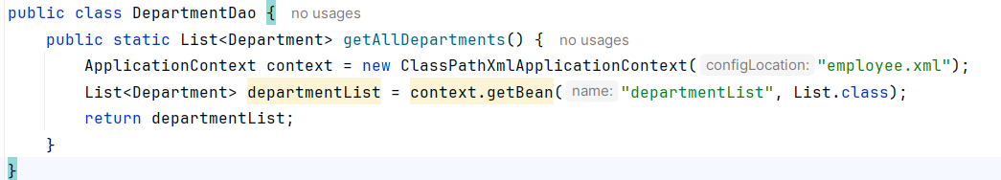

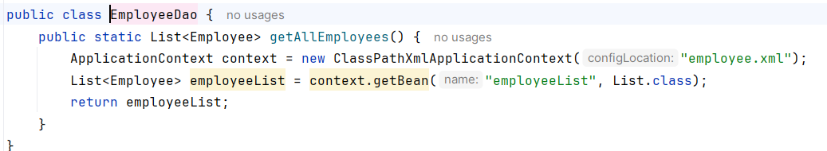

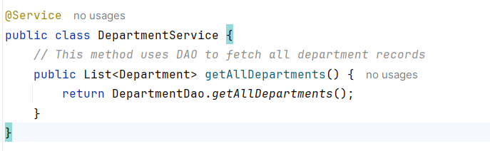

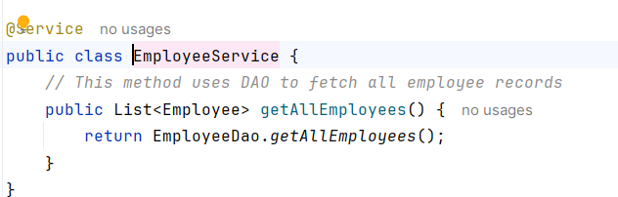

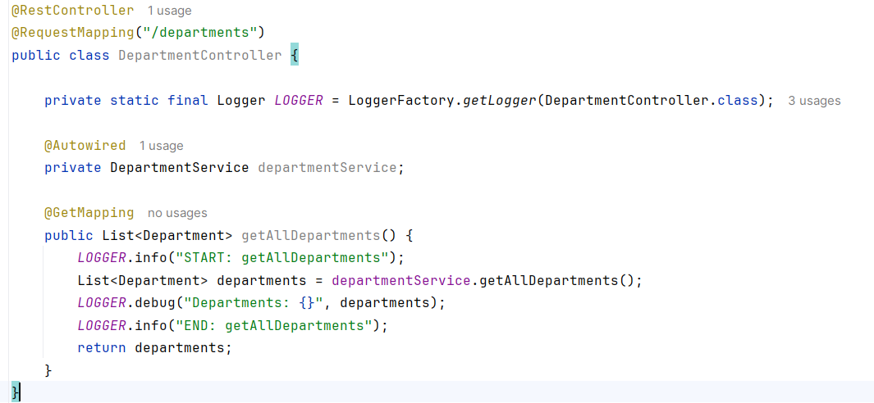

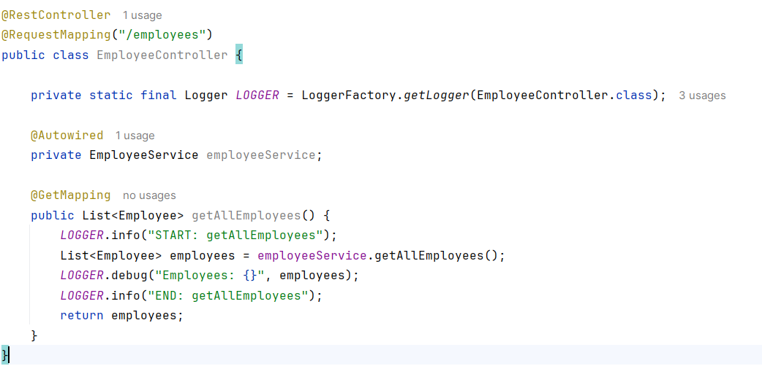

**OUTPUTS:**

